Jacob Cannamela

CSD-340

1/21/2025

Module 5

**Front-end Style Guide**

**1. Color Palette**

The color scheme should evoke warmth, heritage, and a sense of timelessness. Here’s a suggested palette based on the story's themes:

* **Primary Colors:**
  + Deep Navy Blue #2C3E50 (Represents tradition and stability)
  + Warm Beige #EAE0C8 (Symbolizes nostalgia and warmth)
* **Secondary Colors:**
  + Soft Olive Green #A3B18A (Connection to nature, growth, and resilience)
  + Rich Burgundy #7D1538 (Family ties, love, and legacy)
* **Accent Colors:**
  + Gold #D4AF37 (Legacy, accomplishments, and treasured memories)
  + Muted Gray #5F6A72 (Balance and wisdom)

**2. Typography**

Choose fonts that combine a traditional serif with a modern sans-serif for readability and character.

* **Headings (H1, H2, H3):**
  + Font: *Playfair Display* (Serif, elegant yet readable)
  + Example: font-family: 'Playfair Display', serif;
  + Style: Bold and capitalized for impact.
* **Body Text:**
  + Font: *Lora* (Serif, warm and inviting)
  + Example: font-family: 'Lora', serif;
  + Style: Regular, line-height for readability.
* **Navigation & Buttons:**
  + Font: *Montserrat* (Sans-serif, clean and modern)
  + Example: font-family: 'Montserrat', sans-serif;
  + Style: Uppercase with slight letter-spacing for clarity.

**3. Spacing & Layout**

Maintain a structured yet inviting layout with generous whitespace to allow the story to breathe.

* **Margins:** 20px around text blocks
* **Padding:** 15px for internal spacing in content sections
* **Line Height:** 1.6 for improved readability
* **Grid System:** Use a 12-column responsive grid to organize content sections effectively.

**4. Components**

**Buttons:**

* Style: Rounded edges for a friendly appearance
* Primary Button:
  + Background: #7D1538 (Burgundy)
  + Text: #FFFFFF (White)
  + Border: None
  + Example: .btn-primary { background-color: #7D1538; color: #FFFFFF; border-radius: 5px; padding: 10px 20px; }

**Navigation Bar:**

* Background Color: #2C3E50 (Deep Navy Blue)
* Text Color: #FFFFFF (White)
* Hover Effect: Subtle underline

**Cards for Images:**

* Border: Soft shadow to give a nostalgic scrapbook effect
* Background: #EAE0C8 (Warm Beige)
* Text Alignment: Centered with captions

**5. Imagery Guidelines**

The images should evoke warmth, connection, and a sense of legacy.

* **Filters:** Apply a soft vintage tone to align with the nostalgic theme.
* **Aspect Ratio:** 4:3 for a classic photo-album look.
* **Borders:** Subtle soft edges or thin frames to match traditional themes.
* **Captions:** Include short sentimental descriptions under each photo.

**6. Links and Interactions**

* **Link Colors:**
  + Default: #7D1538 (Burgundy)
  + Hover: #D4AF37 (Gold) – for a subtle glow effect
* **Transitions:** Smooth 0.3s transition for hover effects.
* **Underline links:** Only on hover for clean design.

**7. Iconography**

Use simple, timeless icons that represent themes like:

* A family tree icon for lineage
* A compass for journey and exploration
* A clock for the passage of time

**8. Example Layout Structure**

Suggested sections for the website:

1. **Landing Page:** A welcoming section with a family quote or a nostalgic image banner.
2. **About Page:** A structured biography with timeline elements and major life events.
3. **Hobbies Page:** Showcasing interests such as military service, family trips, and favorite pastimes.

**Biography of Robert Joseph Moynihan II**

Robert Joseph Moynihan II followed in the footsteps of his father, carrying not only his name but also a strong sense of duty and tradition. Born into a family with deep roots in both America and Ireland, Robert grew up with an appreciation for heritage and the importance of preserving family stories. He dedicated much of his life to serving his country, rising through the ranks to become an officer in the U.S. Coast Guard, where he had a distinguished career spanning multiple decades.

Throughout his service, Robert was stationed in various locations, including Hawaii, Michigan, and Washington, D.C. Despite the demands of his military career, he prioritized his family, creating cherished memories through simple pleasures like weekend trips, home-cooked meals, and meaningful conversations that often revolved around their rich family history. His leadership extended beyond the military; he was a 33rd-degree Scottish Rite Freemason, a testament to his commitment to moral and personal development, as well as his dedication to the principles of brotherhood and service.

After retiring from the Coast Guard in 1989, Robert and his wife Carolyn settled in Martinsburg, West Virginia, before eventually finding their forever home in The Villages, Florida. His legacy is one of dedication, love, and resilience. These are values that he instilled in his children and grandchildren. His commitment to family ensured that future generations would always have a sense of belonging and appreciation for their roots.

**Wireframe:**

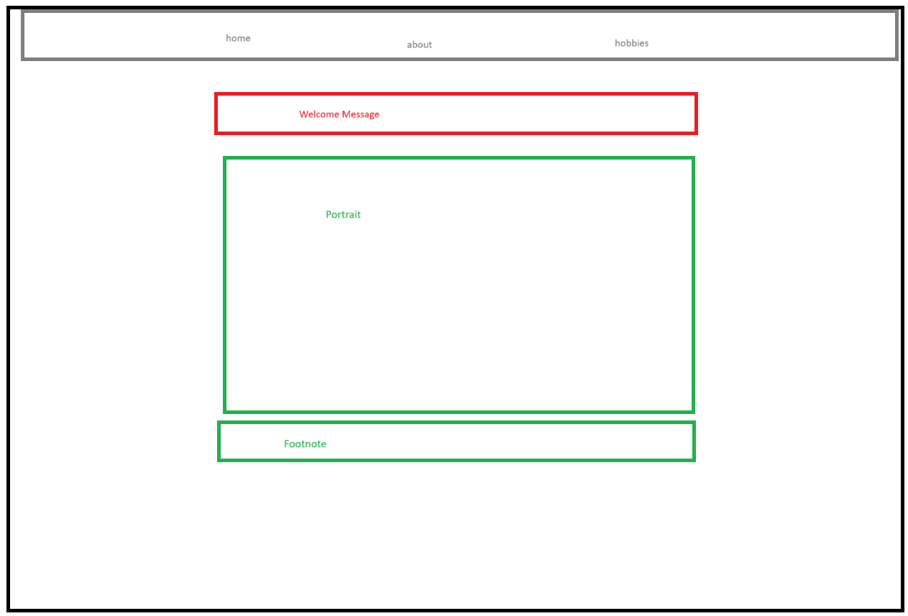

**Portrait**

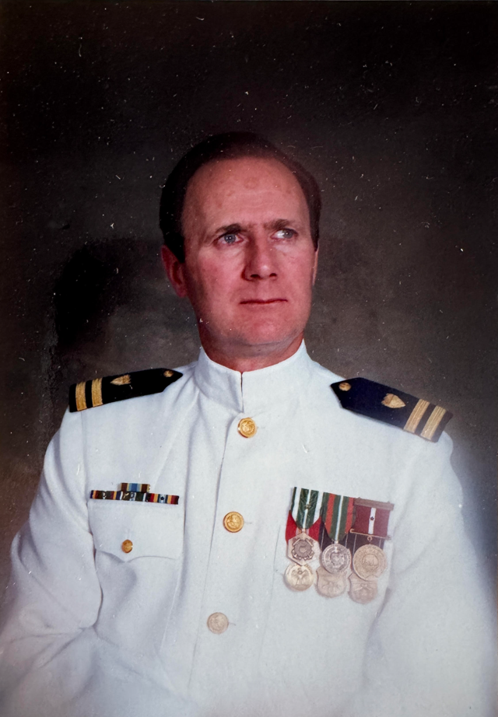

**Achievement photos:**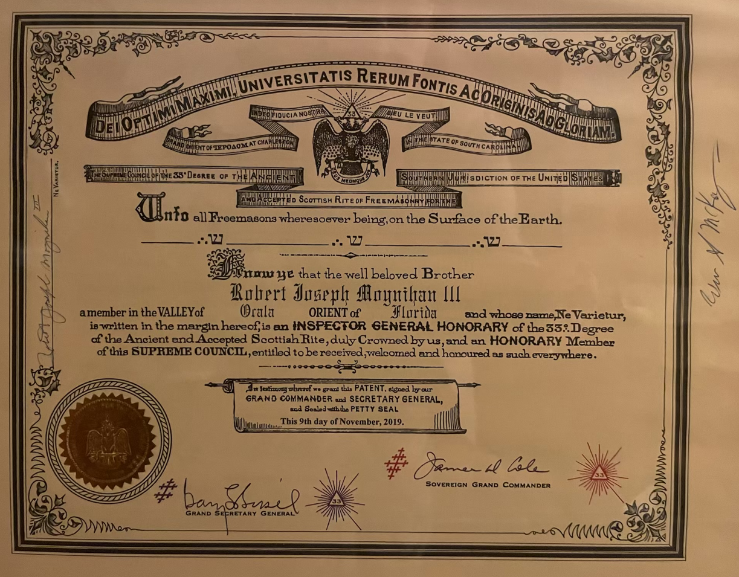

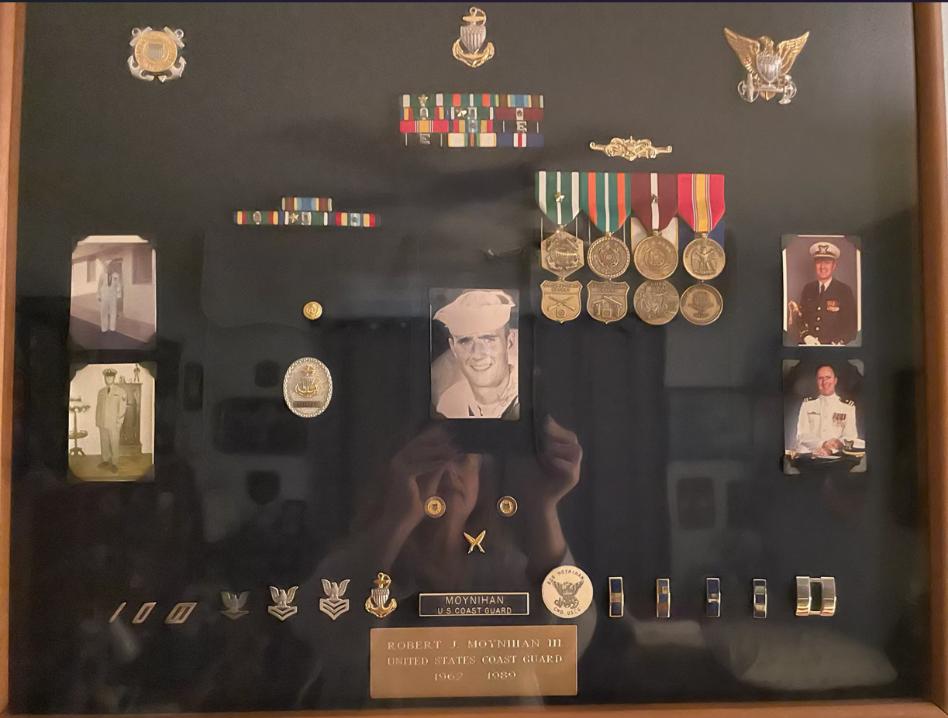

**Hobbies:**

